Alternative short versions:
MSE Cheat Sheet.pdf
MSE Definitions.pdf
Quick_reference_guide.pdf
Mental Status Exam Cheat Sheet | PDF | Affect (Psychology) | Mental Health
Or more detailed article below
Ten Point Guide to Mental State Examination (MSE) in Psychiatry
Posted on:November 30, 2020
Last Updated: November 30, 2020
Time to read: 14–17 minutes
The mental state examination [MSE] is an integral, and essential, skill to develop in a psychiatric evaluation. The undertaking of an accurate MSE helps elicit signs and symptoms of apparent mental illness and associated risk factors.
- The MSE is a structured tool and process that allows you to observe and assess a patient’s current mental state. It can also be helpful to use as part of a working diagnosis and identifies possible areas for intervention. MSEs are usually incorporated into every mental health assessment and clinical contact.
Key principles in the approach to MSE:
- Welcome the patient, state the reasons for meeting and make them feel comfortable.
- Maintain privacy, encourage open conversation and always acknowledge and respect the patient’s concerns and distress.
- Write down the patient’s words and the order in which they are expressed verbatim. This should avoid misinterpretation.
- Take into account the patient’s age, culture, ethnicity, language and level of premorbid functioning. (e.g. Is an interpreter required to make the assessment fair and accurate?)
- Consider physical health problems which can impact the mental state.
- The MSE is not to be confused with the Mini-Mental State Examination (MMSE), which is a brief neuropsychological screening test for cognitive impairment and suspected dementia. However, the MMSE can be used for more detailed testing in the cognitive section of this MSE.
- This MSE includes all 10 aspects: appearance, behaviour, speech, mood, affect, thoughts, perception, cognition, insight and judgement and clinical judgement. Rapport may also be included.
- The undertaking of an MSE requires time. If this is not possible [perhaps due to environmental pressures], the focus must be upon risk. (See later)

1. APPEARANCE
Observing a patient’s appearance can help you identify clues about their mental status. It is important to recognise that if a patient appears ‘well-groomed’, this does not mean that their mental state is well.
It is also important to ask the patient if they find attending to their personal care difficult in any way, if they need prompting or if they require help physically doing so.
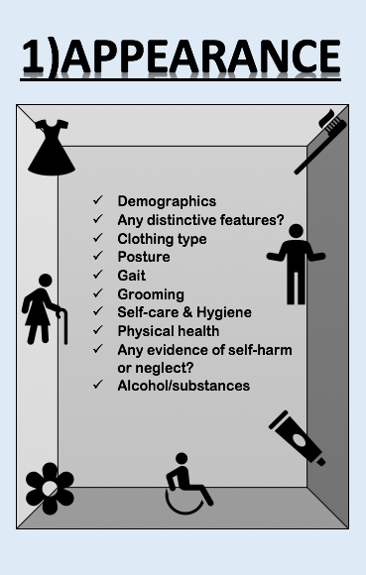
Patient demographics:
- Age, gender, D/O/B, religion, ethnicity…
Clothing type:
- Have they dressed appropriately for the season, setting and occasion?
- Did they choose clothes that reflect their mood? (Bright/dark/dull)
- Are their clothes clean and in wearable condition?
- Do their clothes have any emblems or logo’s which may indicate substance misuse? (E.g. Cannabis leaf on the T-Shirt / Alcohol branding on clothing etc.).
Posture:
- Is their posture closed, slouched or open? Is there any sign of postural instability?
Gait:
- Brisk/slow/hesitant/propulsive/shuffling/ataxic/uncoordinated?
Grooming, self-care and hygiene:
- Has the patient stopped looking after themselves recently? Do they need help/prompting with personal hygiene?
Physical Health:
- Has there been a comprehensive physical health assessment?
- Are they currently experiencing any pain?
- Are there any biological symptoms, e.g. diurnal variation, sleep pattern, appetite, libido, lack of energy?
Alcohol & Substances:
- Do they use any psychoactive substances?
- If so, which ones and how often?
- Are they currently abusing alcohol?
- Look for signs of withdrawal (tremor at rest/ tachycardia/ pallor/ perspiration.
- Also look out for neurological signs, i.e. Ataxia, Nystagmus/Ophthalmoplegia/Dysarthria/Peripheral neuropathy.
- Motivational interviewing techniques are incorporated as part of mental state examination to enhance rapport and elicit history taking. See video at the end.

2. BEHAVIOUR
A patient’s non-verbal communication may indicate some insight into their current mental state. Behaviour is commonly misinterpreted in mental health services and should never be described in a stigmatising or patronising way such as ‘good’, ‘odd’ or ‘attention-seeking’. Use language that is constructive, useful and specific.
In addition, it is good to observe ‘Attitude’ – e.g. Cooperative, hostile, open, secretive, evasive, suspicious, apathetic, distracted, focused, defensive.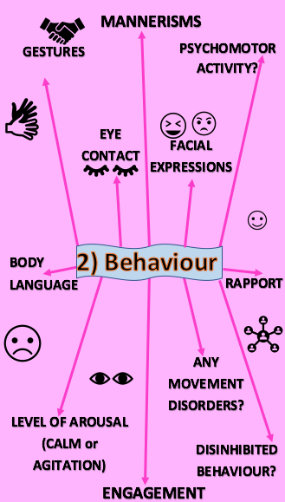
Gestures:
- A gesture is an integral feature of non-verbal communication. It serves an outward manifestation of several fundamental processes including language, sensory integration and motor behaviour. Gestures have been linked to semantic retrieval, learning and communicative ability.
Mannerisms:
- Mannerisms can be a symptom of various psychiatric disorders e.g unusual repetition, compulsions and rituals?
Eye contact & body language:
- Can they maintain eye contact?
- What does their posture imply? Open/closed/engaged/poor/distracted?
Facial expressions:
- Expressive/relaxed/smiling/laughing/happy/anxious/sad/alert/angry/distrustful/suspicious/tearful.
Psychomotor activity:
- Any motor or physical activity? e.g rapid talking, pacing around the room, tremors, foot tapping, psychomotor slowing (consider depression) or elation?
Disinhibited behaviour:
- A disregard of social conventions that affects motor, instinctual, emotional and cognitive and perceptual aspects.
- Any disinhibition or impulsivity?
Engagement & Rapport:
- Foundation of the assessment. It is important to note if rapport is established. Easy to establish/Difficult/Easier overtime/Tenuous/Good/Poor/uninterested?
Level of arousal:
- A function of alertness, situational awareness, vigilance, level of distraction and attention.
- Any signs of delirium, hyperarousal, anxiety?
Abnormal movements:
They may indicate underlying organic conditions or medication-related side effects. if patients are on antipsychotic medications a full extrapyramidal side effect exam should be carried out. (See videos at the end)
- Oro-buccal dyskinetic movements
- Tics
- Akathisia
- Parkinsonian Tremor
- Choreiform movements
- Dystonia
- Catatonic features

3. SPEECH
Speech is assessed by observing and listening to the patient’s spontaneous speech.
Note any paralinguistic features such as volume, rhythm, prosody, intonation, pitch, phonation, articulation, quantity, rate and latency of speech.
- Rate and flow: normal, rapid (mania), slow (depression), a paucity of content (depression and negative symptom of schizophrenia), short monosyllabic answers to questions, pressure of speech (mania)
- Quantity: Talkative, spontaneous, expansive, paucity, poverty?
- Prosody / Tone: Dull, monotonous speech (depression), normal prosody (usual intonation and lilt) or Loud/ whispered, tremulous
- Fluency and rhythm: Slurred, clear, hesitant, articulate, aphasic?
- Route: Circumstantial speech (Obsessive traits, anxiety) / Tangential (mania)
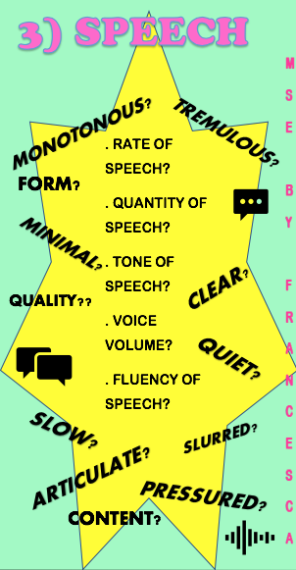
Neurological conditions such as stroke or dementia can present with aphasia (the inability to comprehend or formulate language because of damage to specific areas of the brain.)
Aphasia can also be a result of brain tumours, infections or neurodegenerative diseases).
People with autism spectrum disorders may have abnormalities in paralinguistic and pragmatic aspects of their speech.
Echolalia [repetition of another person’s words] and palilalia [repetition of the subject’s own words] can be heard with patients with autism, schizophrenia or Alzheimer’s disease.
Are any of the words used ‘made up’ [neologisms]?
Gross disorganisation of speech could indicate a psychotic disorder. Speech content should be noted in the thoughts section of this MSE.

4. MOOD
Mood and affect are both related to emotion, but they are different.
Both the subjective and objective aspects of mood should be assessed.
The mood is the patient’s pervasive and sustained emotional state and usually shows the underlying emotion of the person.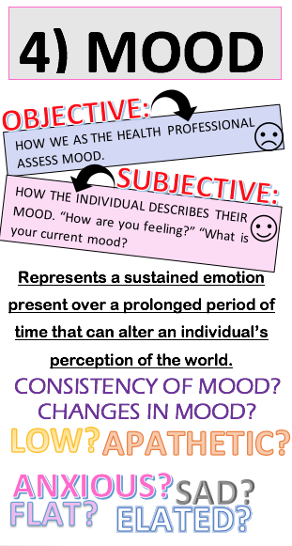
Objective (How we observe and describe their mood):
- Elated, dysthymic, euthymic, apathetic, blunted, depression (mild/moderate/severe), irritability, anxious?
- Does their mood change throughout the meeting?
- What is the constancy of mood?
Subjective (As reported by the patient and observed by the examiner):
Ask the patient to describe how they are feeling and if they are experiencing any biological symptoms as a result of their mood-for example, insomnia or appetite. Make sure you note their exact words and verbatim. Example questions to encourage a subjective answer:
How have you been feeling recently?
How have your energy levels been?
Have you been sleeping and eating well?
Have you felt irritable, angry, depressed, discouraged or unmotivated recently?

5. AFFECT
Affect is a patient’s moment to moment expression.
This is assessed through posture, movements, body, facial expressions and tone of voice.
You do not ask any questions in this section; it’s purely observational.
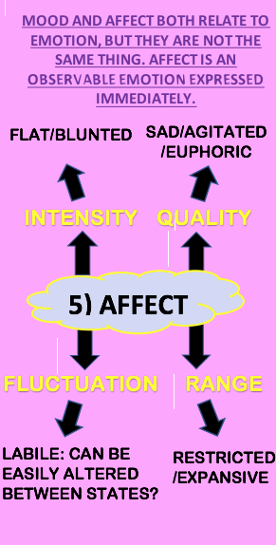
Descriptors include:
- Intensity: Normal, blunted, flat?
- Quality: Sad, agitated, hostile?
- Fluctuation: Labile- easily altered?
- Range: Restricted, expansive, normal?
- Congruence: Congruent / incongruent

6. THOUGHTS
Example questions to assess thought include:
What’s been on your mind recently?
Are you worried about anything?
Have you felt that life isn’t worth living?
Do things seem unreal to you?
Do you think anyone is trying to harm you?
Are there thoughts that you have a hard time getting out your head?.
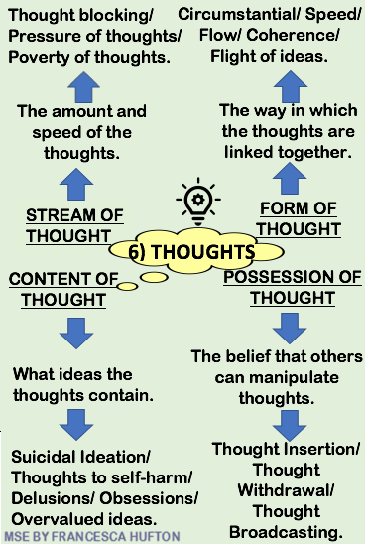

Stream of thought:
- The quantity and speed of the thoughts- Are they blocking any thoughts? Are they pressured? Poverty of thoughts?
Form of thought:
- Is what the patient saying logical? Are the thoughts and linked together- are they tangential?
Possession of thought:
- Any thought insertion, thought withdrawal or thought broadcasting identified?
Content of thought:
- Everything that the patient discusses during the meeting. Were any delusions, obsessions, paranoia or phobias identified?
- Their thought content may include reference to suicidal ideation, self-harm, violence, vulnerability or plans to abscond (if inpatient)?
Phenomenology of Thought Form:
Flight of ideas:
- A nearly continuous flow of accelerated speech with abrupt changes from topic to topic that are usually based on understandable associations, distracting stimuli, or plays on words. When severe, speech may be disorganized and incoherent.
Tangentiality:
- Replying to a question in an oblique or irrelevant way.
Poverty of Thought
Word Salad:
- Speech or thinking that is essentially incomprehensible to others because words or phrases are joined together without a logical or meaningful connection
Derailment (“loosening of associations”):
- A pattern of speech in which a person’s ideas slip off one track onto another that is completely unrelated or only obliquely related
Clang Associations:
- A type of thinking in which the sound of a word, rather than its meaning, gives the direction to subsequent associations.
Pressure of speech:
- Speech that is increased in amount, accelerated, and difficult or impossible to interrupt.
Poverty of thought:
- Reduction in the quantity of thought
Blocking:
- A sudden interruption of thought or speech.
Mutism:
- Refusal to speak.
Echolalia:
- Meaningless repetition of the nurse’s words.
Neologisms:
- New words formed to express ideas
Phenomenology of Thought content:
Suicidal and Homicidal ideation (Risk assessment)
Obsessions:
- Recurrent and persistent thoughts, impulses or images that are intrusive and cause marked anxiety or distress.
Compulsions:
- Repetitive behaviours (e.g. washing, ordering, checking, hoarding) or mental acts (e.g. praying, counting, repeating words silently) that the person feels compelled to perform in response to obsessive thoughts.
Preoccupation / Worry:
- Perseverative cognition that tends to be anchored around the sustained processing of uncertainty.
Rumination:
- Sustained processing of negative material.
- Repetitive and passive thinking that dominates attention.
- A tendency to continue to think about something bad, harmful, or unhopeful for a long time.
- Prolonged processing of self-referent material is due to an impairment in the ability to disengage one’s attention
Overvalued ideation:
- An unreasonable and sustained belief that is maintained with less than delusional intensity (i.e. the person is able is to acknowledge the possibility that the belief may or may not be true).
Delusions:
- False beliefs based on incorrect inference about external reality that is firmly sustained despite what almost everyone else believes and despite what constitutes incontrovertible and obvious proof or evidence to the contrary.
Ideas of reference and Delusions of Reference:
- A delusion whose theme is that events, objects, or other persons in one’s immediate environment have a particular and unusual significance.
- These delusions are usually of a negative or pejorative nature, but also may be grandiose in content.
- This differs from an idea of reference, in which the false belief is not as firmly held nor as fully organized into a true belief.
Examples include:
- Grandiose delusions (mania)
- Persecutory delusions
- Nihilistic delusions (psychotic depression)
- Delusions of guilt and sin (psychotic depression)
- Passivity phenomenon (the belief that impulses, actions or feelings are controlled by an external force; occurs in schizophrenia)
- Thought interference (the belief that thoughts can be put into (thought insertion), taken out (thought withdrawal) or broadcasted so that other people know what you are thinking (thought broadcasting).

7. PERCEPTION
The process of becoming aware of what is presented to the body through the body’s sense organs. It is also important to consider other health conditions such as autoimmune diseases, which can mimic mental illness and can change a person’s perceptions. [Autoimmune conditions masquerading as psychiatric illness]
Consider the presence of hallucinations and illusions here [a hallucination can be defined as perception in the absence of stimulus; illusions are defined as a misinterpretation of stimulus].
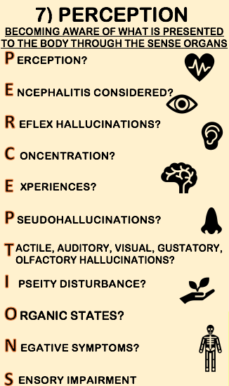
P = Perception:
- Have the individual’s perceptions changed recently?
- Are they experiencing any hallucinations, delusions, illusions or other perceptual abnormalities?
- Other perceptual abnormalities and types of hallucinations are described further below.
- Acknowledge any distress these perceptions may be causing the person.
E = Encephalitis:
- Anti-NMDA receptor Encephalitis can present with psychotic symptoms.
- Has the patient had acute psychotic symptoms?
- Have they recently had a tumour?
- Have they experienced adverse effects on antipsychotics?
- Are they experiencing hallucinations, seizures, severe anxiety, movement disorders, distorted vision and a decreased level of consciousness?
R = Reflex Hallucinations and further types of perceptual abnormalities:
- Reflex Hallucinations: Stimuli in one sensory modality causing a hallucination in a different sensory modality- i.e. music causing visual hallucinations
- Functional hallucinations: Stimuli in one sensory modality causing a hallucination in the same sensory modality- i.e. music causing auditory hallucinations
- Hypnagogic and Hypnopompic hallucinations: Occurs at the point of falling to or waking from sleep; usually brief
- Extracampine hallucinations: the feeling of a silent, emotionally neutral human presence, perceived not as a visual hallucination but as a vague feeling of somebody being near.
- Lilliputian hallucinations: a perception that items, people, or animals seem smaller/larger than they would be in reality. Depersonalisation assessed and recorded within this area. In addition, consider ‘Derealisation,’ i.e. Does the environment feel unreal to them? Are there any over-valued ideas?
C =Concentration:
- Has the individual had difficulties concentrating since experiencing perceptual changes?
- Sometimes those who have perceptual abnormalities often have trouble keeping track of their thoughts and conversations.
- Some people may find it hard to concentrate and will drift from one idea to another.
- Are they having trouble reading a newspaper, watching a TV programme or concentrating at work, studies or with general daily life?
E = Experience:
- How does the individual respond or describe their experiences with perceptions?
- Has the environment changed for them?
- Have there been changes in the frequency and intensity of external stimuli? Is it reliable?
- If hallucinations are auditory, are they in 2nd or 3rd person? 2nd person hallucinations may be a command with the voice talking to them.
- 3rd person hallucinations may be the voices speaking about them or referring to them. If more than one voice, sometimes the voices can argue with each other.
P = Pseudohallucinations:
- Pseudohallucinations are similar to hallucinations but fall short of some of the standard characteristics found in psychotic symptoms.
- Not perceived by the actual sense organs, but experienced as emanating from within the mind
- although vivid, they lack the substantiality of normal perception
- located in subjective (internal), rather than objective (external) space and are useful towards delineating between psychotic and non-psychotic symptoms.
- unwilled, and not subject to conscious control or manipulation
- retention of insight
- not pathognomonic of any mental illness, occur in: can be caused by disorders such as depression, obsessional states, personality disorder, time of crisis, e.g. bereavement, Parkinson’s disease, schizophrenia, and acute delirium in that they are internally inconsistent and are usually symbolic and convey messages that usually convey messages that reflect an individual’s psychological distress.
T = Tactile, Auditory, Visual, Gustatory, Olfactory Hallucinations:
- Are the hallucinations tactile (touch), auditory (audition-hearing), visual (seeing), gustatory (taste), olfactory (smell)?
- Are they experiencing more than one? (Multimodal hallucinations)
- Non-auditory hallucinations can indicate an organic cause. e.g. olfactory hallucinations in temporal lobe epilepsy. [Capampangan D et al., 2010];[Chen C et al., 2003]
I = Ipseity Disturbance:
- This is a disruption or diminishing of a person’s sense of self. Anomalous self-experiences are considered as central features of the schizophrenia spectrum disorders and prodromal schizophrenia. Further testing can be found in the EASE (Examination of anomalous self-experience).
O = Organic States:
- Organic mental disorders are common in organic mental disorders such as Parkinson’s disease.
N = Negative Symptoms:
- The 5 A’s (Affect, Apathy, Alogia, Avolition, Anhedonia)
- Use the Scale for the Assessment of Negative Symptoms (S.A.N.S for assessing negative symptoms).
S = Sensory Distortions and Deceptions:
- Do they perceive objects in a distorted way? Are they having new perceptions that may or may not be a response to stimuli?

8. COGNITION
This section of the MSE covers the patient’s level of orientation, attention, memory, alertness and visuospatial functioning.
The cognition section assesses their awareness of self, their environment, higher cortical functioning, frontal functioning, language, mental calculation, drawing and copying.
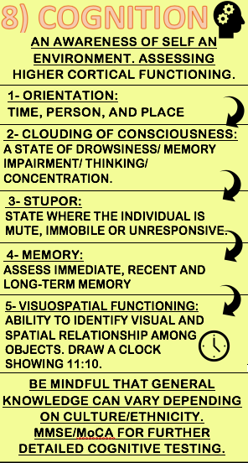
Very Important: Please ensure that you are mindful of language barriers, age and ability for accurate and fair testing.
Orientation:
- Consider the level of consciousness by assessing their orientation.
- Can the patient accurately answer the time, their date of birth, their age, and the place they currently are at?
- Is there an awareness of the current setting?
- “What is your full name?” “How would you describe the situation we’re in?”.
- What was their score?
- Repeat if necessary.
- Further testing can be done when required for naming and comprehension difficulties, dysgraphia, left-right orientation, verbal fluency, sensory and visual inattention and perseveration.
Clouding of Consciousness:
- A state of drowsiness with possible impaired attention, memory and thinking. E.g. Vigilant, alert, drowsy, lethargic, confused, labile?
Stupor:
- A state whereby the patient is mute, immobile or unresponsive.
Memory:
- Test recent, immediate and long-term memory. Example questions for:
1.Recent memory:
What time was your appointment with me today?
What did you do last night?
2. Long term memory:
What date did you get married?
What school did you go to?
3. Immediate memory:
Give the patient objects to remember and then ask them to repeat them back to you (Refer to the Mini-Mental state examination or MoCA for detailed assessing).
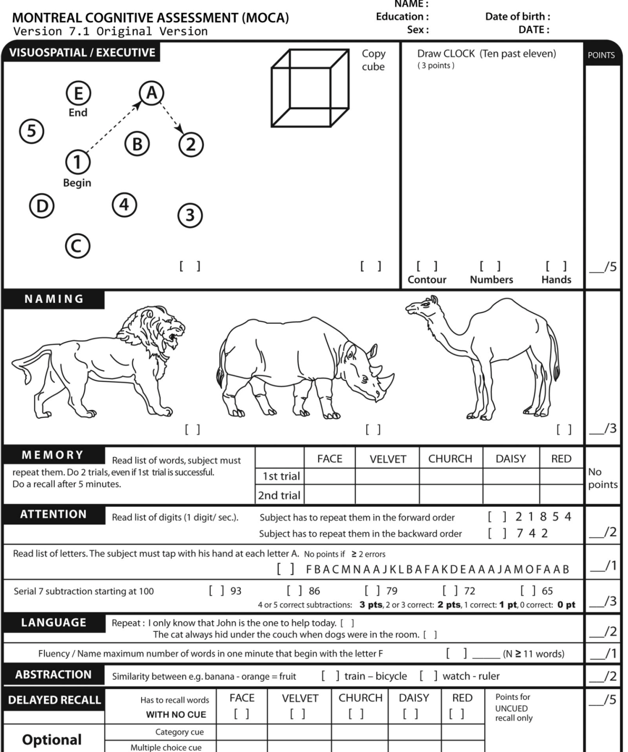

MMSE:
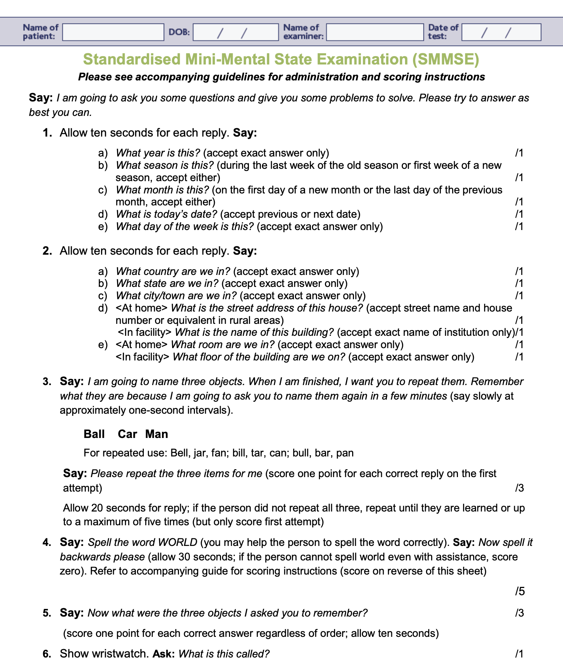
Visuospatial Functioning:
- The ability to identify the visual and spatial relationship among objects.
- This can become impaired in neurodegenerative diseases, encephalitis and other autoimmune disorders.
- Visuospatial functioning is usually significantly impaired in dementia, Alzheimer’s disease and vascular dementia. Furthermore, visuospatial skills are more likely to be more prominent than memory in vascular dementia.
- This is because visuospatial skills rely on parietal lobe functioning, which mainly handles information from our senses about space, perception and size.
Frontal Lobe Examination:
- The frontal lobe is the seat of executive function.
- In clinical practice, a clinician should have a high index of suspicion of possible frontal lobe involvement in treatment-resistant disorders as many clues to frontal lobe involvement come from subtle signs and collateral history, e.g. change in personality, fatuousness, untidiness, slowness of action and thought, perseveration, etc. which is not always evident on a cross-sectional interview.
- A cognitive examination involving the frontal lobe can uncover this to a large extent.
- The Frontal Assessment Battery (FAB) is a brief tool that can be used at the bedside or in a clinic setting to assist in discriminating between dementias with a frontal dysexecutive phenotype.
- Read more about the importance of frontal lobe and cognitive examination of the frontal lobe.

9. INSIGHT AND JUDGEMENT
The patient’s understanding of their mental health problem is evaluated by gathering as much information as possible from their perspective. Judgement is assessing the patient’s general problem-solving ability.
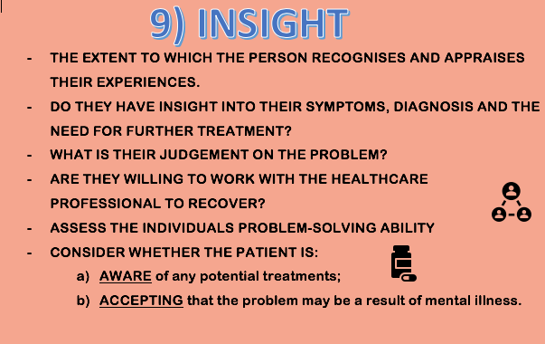
Important: Having insight into a problem does not necessarily mean that their mental health is okay.
- How do they appraise their illness?
- What would they like the outcome to be following the assessment?
- Is their opinion of their problem congruent with the clinician?
- Was there any transference or countertransference during this assessment?
- Are they able to re-label experiences as part of the illness?
- Are they willing to work with you and other health professionals to get well again?
- Do they have culturally alternative explanatory models of diagnosis and treatment?
- Are there factors that would affect adherence? [Read more]

10. CLINICAL JUDGEMENT AND RISK ASSESSMENT
- Summarise your findings and explain to the patient what the potential next steps are.
- Collaborate with other professionals, make any relevant referrals and phone calls and formulate a plan ASAP.
- Most importantly, make sure that the patient has everything communicated to them and keep them updated.
- Be open and honest if a referral may take some time.
- Does anything need communicating to their next of kin?

- Summarise findings.
- Complete a risk assessment.
- Arrange and perform any further tests that may be needed for clearer answers.
- Are there any safeguarding concerns alerted during this assessment?
- Have you got all information and history from their GP?
- Do you have a good idea of where to go from here? If not, liaise with other staff members.
Key aspects of a risk assessment:
- Physical risk: diabetes, medical complications in Anorexia nervosa, other medical conditions
- Suicide risk and risk of self-harm
- Homicide Risk: HCR-20 can be a useful tool to assess the risk of harm.
- Risk to reputation
- Risk to finances
- Risk of exploitation
- Risk of driving
- Risk to children
- Corporate Risk: ongoing employment that would put the organisation and public at risk
- Mention management of safety, e.g. MHA, nursing observations

CONCLUSION
AND LAST, BUT NOT LEAST….
VERY IMPORTANT:
Thank the person for their time meeting you today and for being open with you. Explain what will happen next!

Click the Image to Download the Infographic PDF
